React Assignment:

1. Create a layout like the below image. Here you have to define a header,a navbar,a footer, one sidebar and one main component. Here all the menu name, Content, Sidebar content will be passed from the parent app component as props. Here use different css for your components.

**Employee Management System**

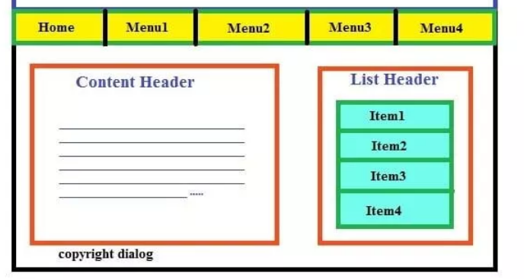

1. Create A react app , that will display this layout. Here also we will pass the content for every component as props from the parent. Define multiple components here. And use these components in your App component.

